# CS 255 System Design Document Template

## UML Diagrams

### UML Use Case Diagram

### UML Activity Diagrams

Reserve Driving Appointment Use Case:

Login Use Case:

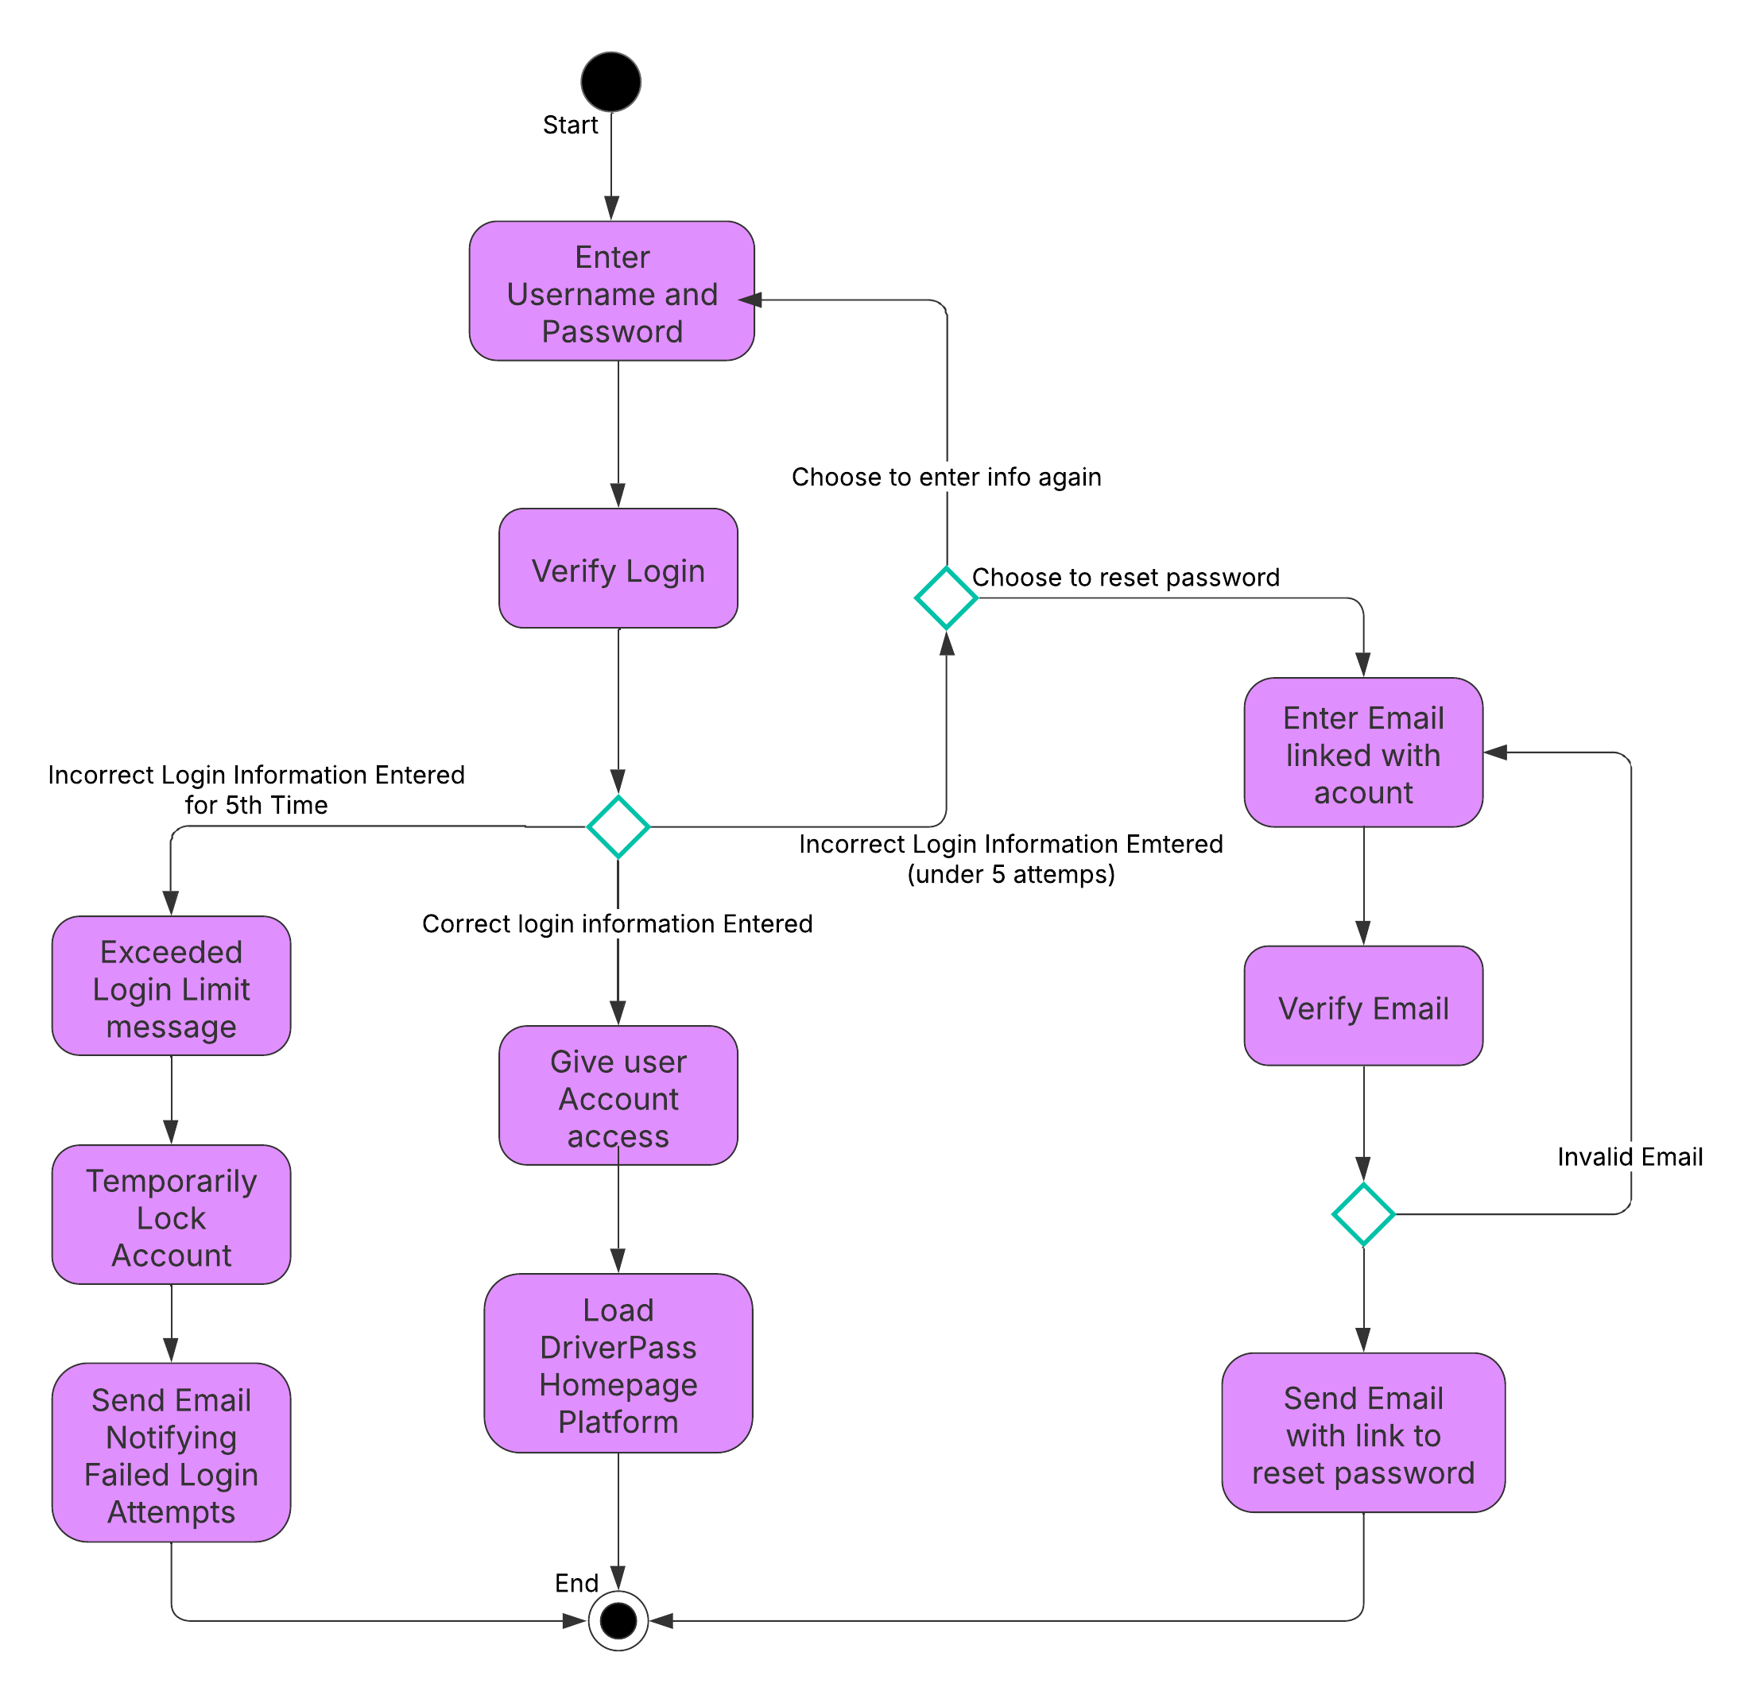

### UML Sequence Diagram

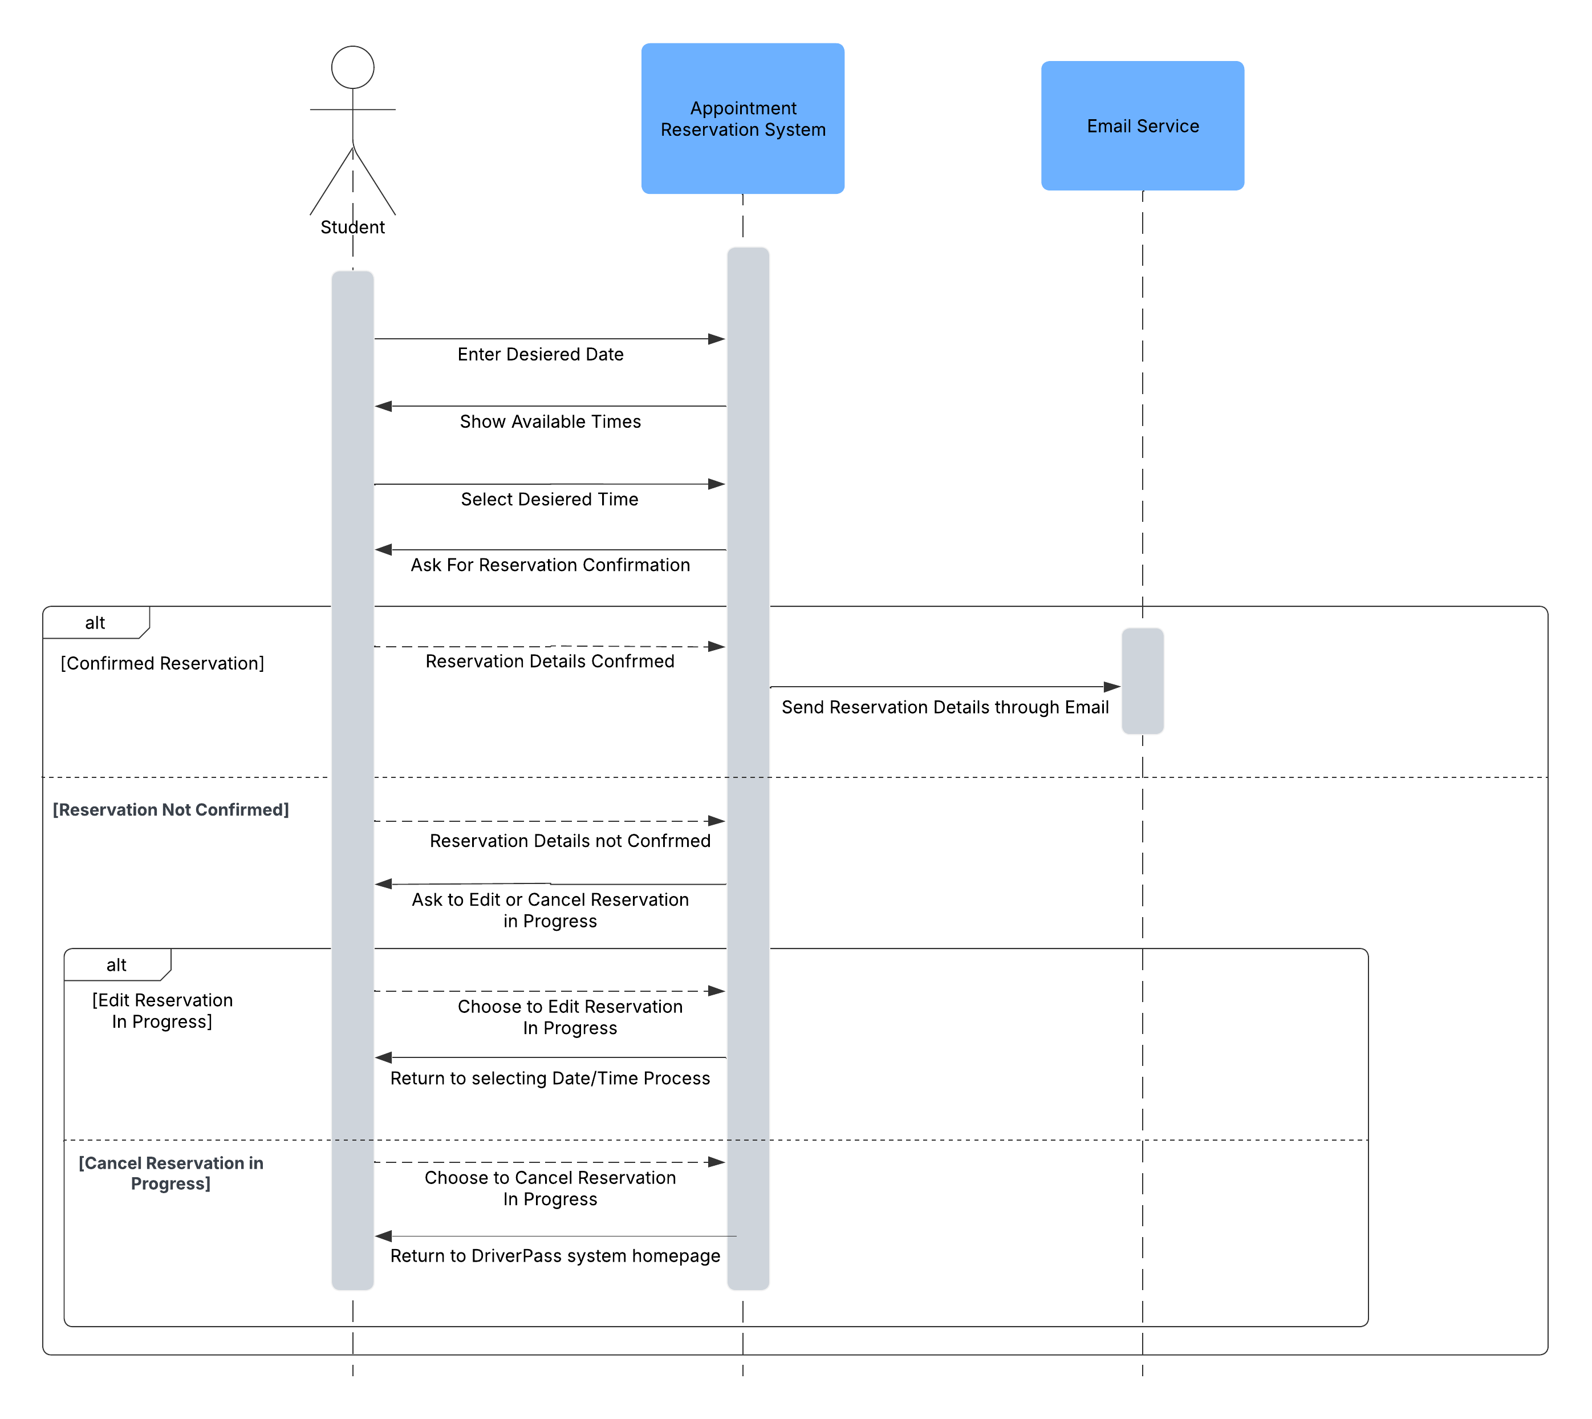

### UML Class Diagram

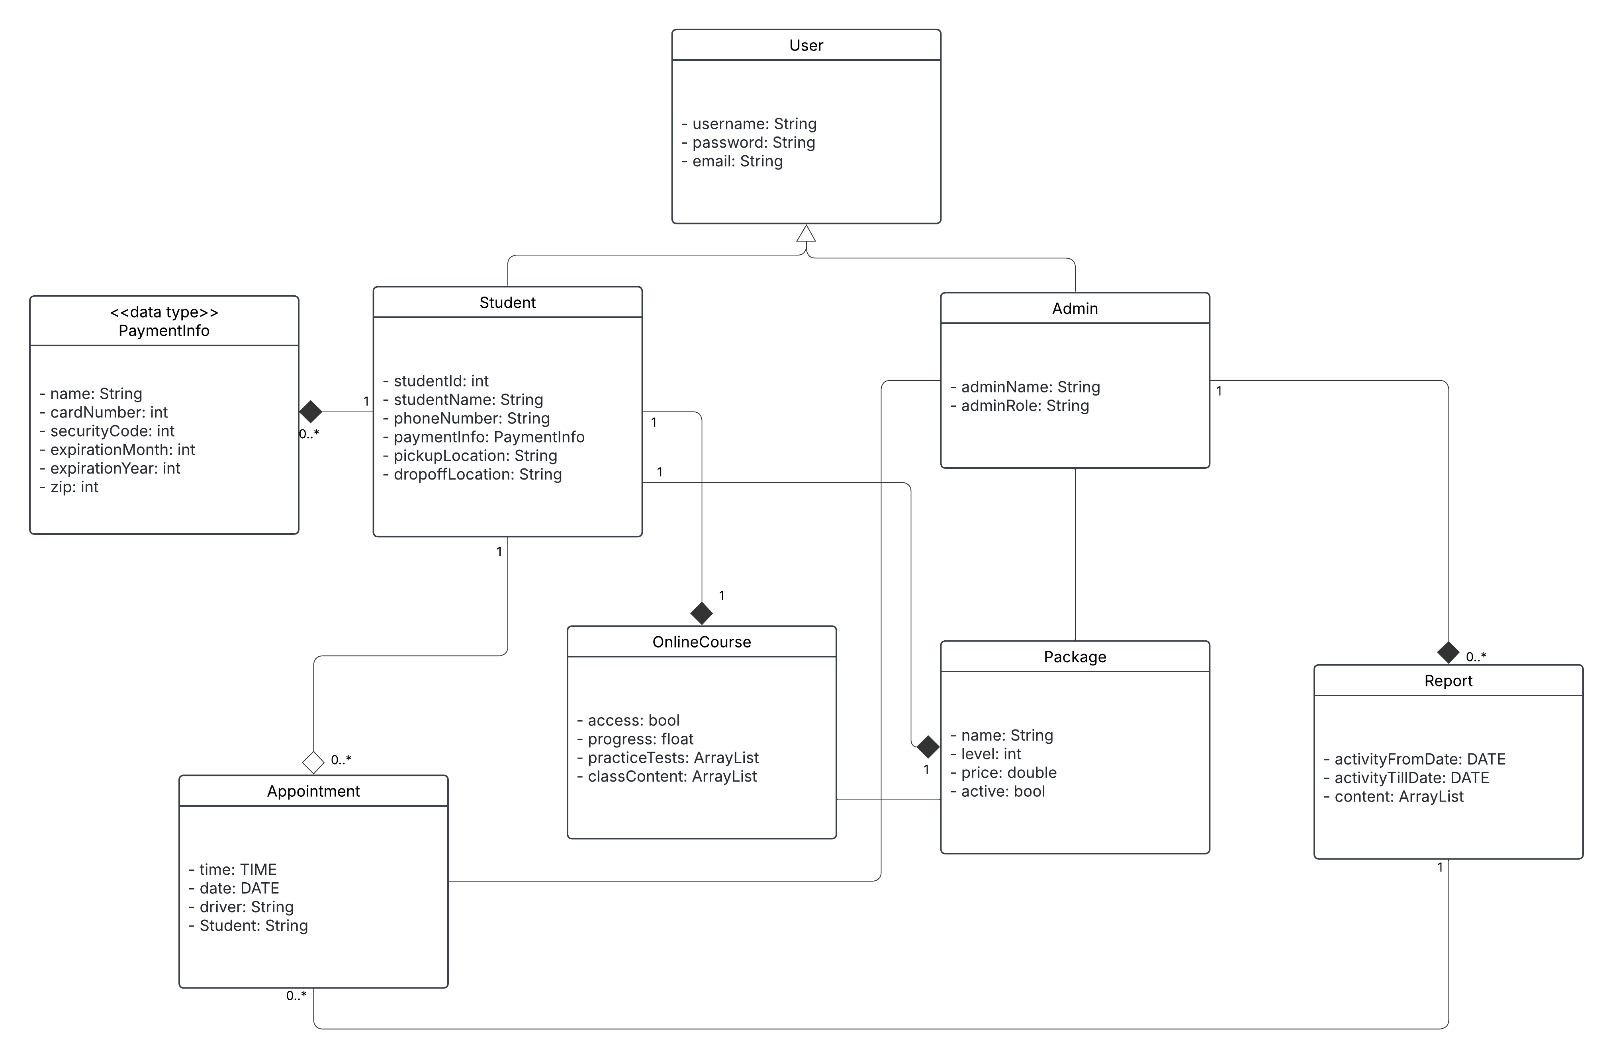

## Technical Requirements

Hardware Requirements:

* Servers: The system will run on cloud servers so it can handle more users as needed.
* User Devices: Students and admins should be able to use the system on computers, tablets, and smartphones.
* Internet Connection: A stable internet connection is required so users can book appointments, take online courses, and access materials in real time.
* Security Measures: The system must have firewalls and encryption to keep user data safe.

Software Requirements:

* Operating System: The system should work on Windows, macOS, iOS, and Android so users can access it from any device.
* Web Application: The platform should be accessible through common web browsers like Google Chrome, Firefox, Safari, and Edge.
* Database: A relational database like MySQL will help store user accounts, test results, and appointment details.
* Payment System: The system should connect with secure payment processors like Stripe or PayPal to handle online transactions.
* Security Features: SSL/TLS encryption should be used to protect user data, and multi-factor authentication should be used for login security.

Tools:

* Front-End: The system should use React.js or Angular to create a smooth and easy-to-use interface.
* Back-End: A framework like Node.js should be used to handle system functions and connect with the database.
* Cloud Hosting: The system will run on cloud platforms like AWS, Google Cloud, or Azure to ensure reliability.
* Version Control: Developers will use GitHub to manage and update the system’s code.
* Testing Tools: Automated testing tools like Selenium will check for errors before updates are released.

Infrastructure:

* Cloud Storage: Online course materials and documents will be stored using AWS S3 or Google Cloud Storage.
* Data Backups: The system should automatically back up user and transaction data to prevent loss.
* Scalability: The platform must handle many users at once without slowing down.